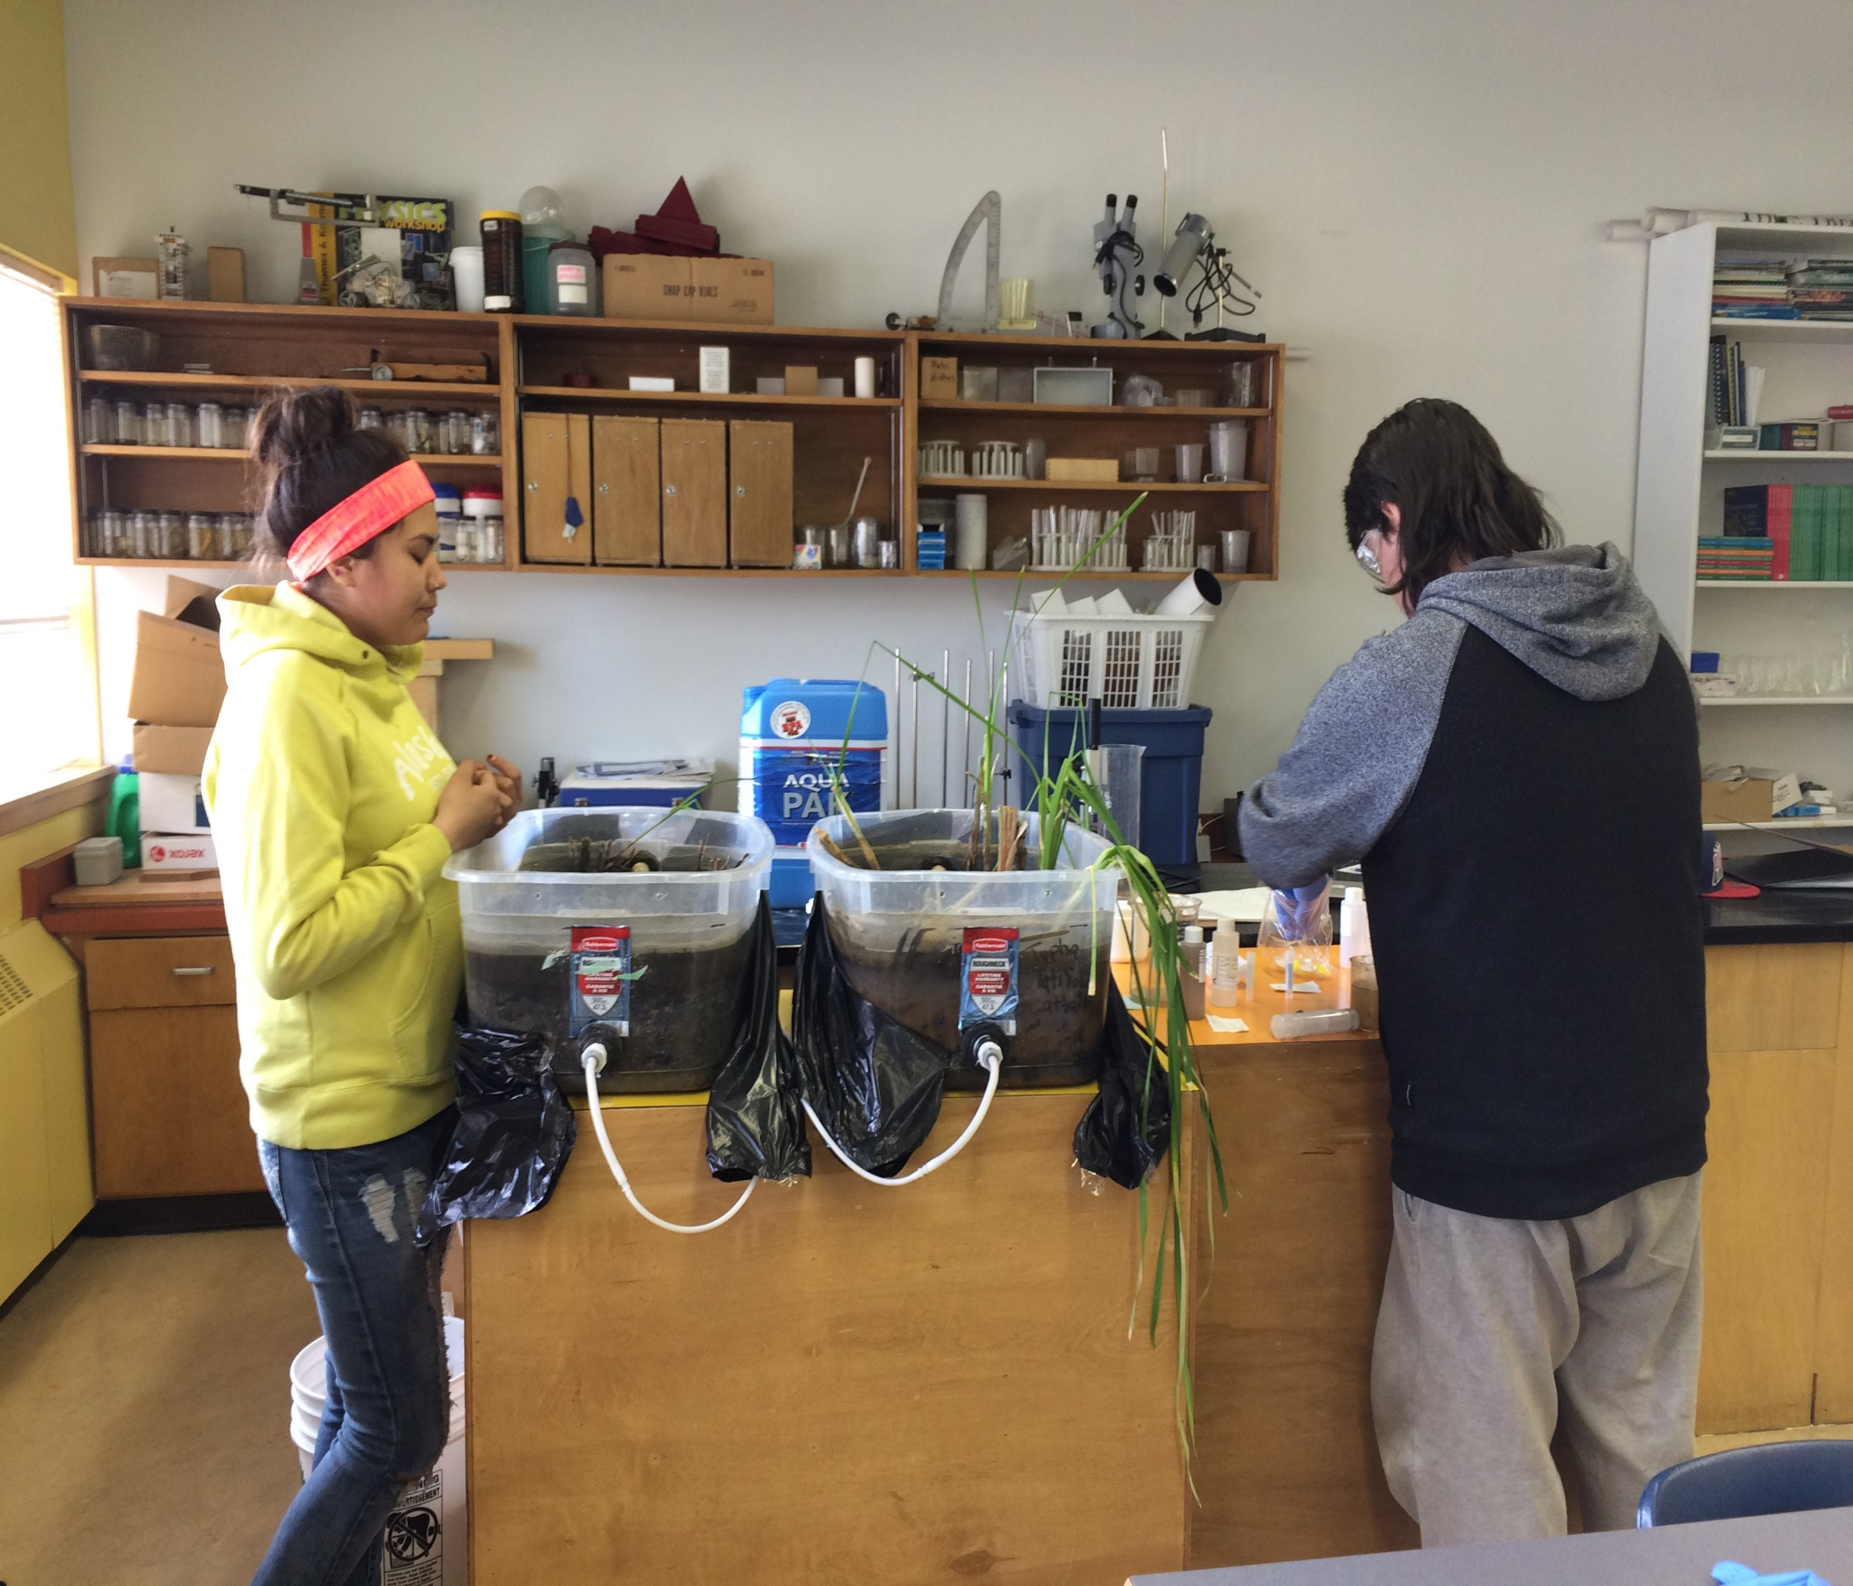
Northern Mine Remediation
Final Activity Report

This publication may be obtained from:
Yukon Research Centre, Yukon College
500 College Drive
PO Box 2799
Whitehorse, Yukon
Y1A 5K4
867.668.8895
1.800.661.0504
yukoncollege.yk.ca

PROJECT TEAM

Dr. Amelie Janin | Project Director  Industrial Research Chair for Mine Life Cycle, Yukon College 867.668.8881 ajanin@yukoncollege.yk.ca
Sara Thompson | Project Coordinator, Yukon College  867.456.8628  smthompson@yukoncollege.yk.ca

ACKNOWLEDGEMENTS
The project was coordinated by Dr. Amelie Janin, NSERC Industrial Research Chair for Mining Life Cycle, Yukon College.
The Northern Mine Remediation project would not have been possible without the financial support of the Canadian Northern Economic Development Agency (CanNor) and its other funding sources: the Natural Sciences and Engineering Research Council of Canada (NSERC), the Yukon Mining Research Consortium (YMRC) and the Yukon College. This project focused on understanding how to develop and/or adapt environmental remediation technologies for the north and fostering knowledge growth in Yukon by cultivating and establishing partnerships and relationships with academic entities, First Nations and communities.
We wish to recognize CanNor and the technicians and students at Yukon College that helped to coordinate this project. Last but not least, we wish to recognize the many community and First Nations members for your support and participation in this project.

TABLE OF CONTEXT
Project Summary…………………………………………………………………………………….......................... | 1
Exposing youth to the science of remediation and restoration……………………………………….. | 2
Engaging First Nations regarding traditional knowledge on plants………………………………..... | 5
Using Bioreactors to test for removal of containments from mine impacted water………… | 6
A plan for a constructed wetland………………………………………………………………………………….... | 7
Performance Measures…………………………………………………………………………………………………… | 7
APPENDIX 1 – Northern Experimental Passive Treatment Facility: Technical Design Report……………..................................................................................................................... | 8

Project Summary
The Northern Mine Remediation project began with the formation of the Yukon Mining Research Committee (YMRC) in 2012. As representatives of the mining industry they wanted to create a platform for industry, Yukon College, First Nations, and governments to work collaboratively in in addressing environmental challenges faced by the mining industry in Yukon and determining effective mechanisms for sustainable, environmentally-safe mining practices. YMRC wanted to increase the knowledge, skills and abilities of Yukoners in environmental research and practice, and have First Nations and local communities affected by the mining industry become knowledgeable and engaged in environmental research. Through an active partnership, the YMRC mandated Yukon College (Dr. Janin) to conduct research at Yukon College to collaborate in the development of the northern mining industry. The Yukon College received CanNor funding in order to complete research activities that will reduce the environmental risks and costs associated with mining in the North.
The Northern Mine Remediation project was crucial to fully understanding how to develop and/or adapt environmental remediation technologies for the north. This project worked to understand how remediation technologies can be most effective for Yukon’s northern climate and useful ways to communicating the results to communities and First Nations. This project took steps towards providing proof of concept for existing and new mining operations by testing bioreactor and wetlands monitoring, and most importantly, sharing this knowledge with communities. Partnerships and relationships have been cultivated and established with academic entities, First Nations and communities to gather scientific & traditional knowledge and foster knowledge growth in Yukon.

Exposing youth to the science of remediation and restoration

People that live near or around an operating mine are the most impacted therefore most affected by the operations of the industry. The town of Pelly Crossing is a rural community and at the time of the projects start, had an operating mine nearby, the Minto mine. The members of the First Nation rely deeply on subsistence hunting and gathering of foods near and downstream from the mine site and are very concerned by potential contamination of their environment.
Constructed wetlands have been proposed as a sustainable and cost effective long-term solution to remove heavy metal from water to be discharged in the environment. However, in the Yukon’s rural communities, the complex scientific mechanisms behind the constructed wetlands are not well understood and there is little known about the positive impacts that constructed wetlands have on the ecosystem. Thus, it is important for the decision makers of Selkirk First Nation (SFN) to be aware of the benefits and concerns of constructed wetlands.
Through a partnership with Selkirk First Nation, Eliza Van Bibber School, mine industry partners and the Yukon College, a pilot scale model of a constructed wetland with field-like conditions has been built in the Eliza Van Bibber School in Pelly Crossing and used as a tangible, visual learning tool that will enhance and compliment the sciences already being delivered to the students. This wetland acted as a tool to advance environmentally responsible technologies and practices through hands-on learning opportunities. In the implementation of this project, there was an attempt to provide a background on the principals of ecological engineering and how it relates to passive water treatment in the north as well as a discussion with the students about potential career options in the community such as environmental monitor, lab analyst, heritage and culture officer and environmental assessment analyst.
Based on a design from consultations with industry and regulators, the students helped construct the wetlands by preparing the containers, inserting the necessary sediment and transplanting two plant species. By being directly involved, the students were able to see and understand the different components that made up a constructed wetland. The curriculum created for the Eliza Van Bibber School exposed the students to constructed wetlands and educated them on the workings of the passive water treatment. The project was designed so that 2 constructed wetlands were built in the science classroom in the school and activities were occurring one day a week with a 80 minute presentation and discussion in the morning and an hands-on activity in the afternoon, either in the science lab or outside. Dr. Janin and her team developed a curriculum for these students so they could understand and participate in all aspects of water purification using wetlands. Topics varied from one week to another with different invited speakers to present and to facilitate the activities. On their scheduled weeks, a diverse team of experts, made up of researchers, industry representatives, Elders and SFN members were arranged to come and teach the high school students different components of constructed wetlands. The students have learned the science behind wetland bioremediation but they have also participated in the techniques used to administer the science. Topics ranged from water quality monitoring, water quality analysis, plant health monitoring, traditional knowledge, soil microbiology, environmental assessment, holistic approaches to mine closure, data reporting. As part of the curriculum for the project, students have measured, collected, and analyzed water samples, compared soil samples of constructed versus natural wetlands, and understood the interconnection between many natural components that make up a wetland. To determine that their constructed wetland was working effectively, the students sampled the metal infused influent and sampled the effluent coming from the constructed wetland. The students then finished the sampling process by sending the collected samples to a laboratory in Whitehorse. Through this process the students learnt how to properly complete a Chain of Custody and to collect samples properly without cross contamination, a skill that will be useful for potential employment opportunities.
Selkirk First Nation plays an important role in meeting the objective of successful First Nation involvement in responsible mining projects in their Traditional Territory. Incorporating scientific knowledge with traditional knowledge is an important step in this process and this project offered an opportunity for SFN youth to learn about innovative ways to address challenges in achieving sustainable mining practices. As constructed wetlands are a recently proven technique that could be used at mine sites in their traditional territory it is important that as youth in the community and members of SFN they have a working understanding of these technologies. This wetlands model has increased public confidence in constructed wetlands as an effective remediation technology for the north as the students are sharing their knowledge with family and community members.
The Northern Mine Remediation project has given the next generation knowledge and awareness of the technologies involved in the environmentally-safe mine closure plans which will help them with future decision making in their traditional territory. Provided through the knowledge transfer in this project, the hands-on experience and exposure to technology, the youth involved in this project will have a skill-set that can help with potential employment in the local skilled workforce that participate in local mine remediation.

In addition, by sharing knowledge as part of the Northern Mine Remediation project, there is an opportunity to increase the number of local people employed by the mines themselves or by the services providers to the mines in Yukon. Through this engagement with the SFN youth, student’s interest in science can be fostered and/or will have provided them with skills that can be used to gain employment by a mine in the future. This will assist in diversifying the economy and retaining youth in the area. As such, these developments are important for potential shared value and positive socio-economic impacts to communities with employment for individuals and sustainable economic development. The generation of income leads to a rise in the standard of living of individuals, families and even communities. Economic benefits from mine operations can also be seen as it will enable the development of skills that can be used elsewhere when a mine closes. By communicating with the public, technical groups and specific government organizations, the northern knowledge database will be expanded, providing First Nations and local communities with greater knowledge in research related to environmentally-safe mining practices.
Identifying the main stakeholders and building the support for this project has been key to the successful establishment of this project. Within the community of Pelly Crossing, Y.T. The First Nations government structure consists of four councillors with representation from each of the two clans, the wolf and crow clans, one chief, a youth and elder’s councillor. As leaders of the community it was essential to get the support of the chief and councillors. This support was re-enforced form the school as a necessary step for the schools involvement, as they have a close relationship with local leadership. Once the support for the project was established, further engagement occurred with the executive director to inform administration and gather support from the Capital and Land and Resource Departments. A major component of the project is to use as much local knowledge as possible thus using the human resources from the Lands and Capital Departments to assist with delivering curriculum.
In parallel, through collaboration with Yukon College and Amelie Janin, the project was presented to local industry partners. Buy-in in this project was evident and additional support was offered to us by Capstone Mining Corp and Casino Mining Corp who are both working within the traditional territory of the Selkirk First Nation. Other local stakeholders also offered their help to us.
Some challenges encountered throughout this project were scheduling conflicts with invited speakers and the available time allotted by the school, as some presenters lived out of territory, travel and accommodation had to be arranged while remaining flexible. Finally, we believe that this project was very successful because it respected the local culture and the indigenous way of doing business. All stakeholders have contributed their time, energy, equipment and material to make up this successful project. We believe personal drive and passionate people and receptive students were the key ingredients.
Engaging First Nations regarding traditional knowledge on plants
An objective of the Northern Mine Remediation project was to engage with YFNs regarding traditional knowledge surrounding plants for restoration and aid First Nations and local communities gain knowledge in environmental research. When wetlands are employed as an option for passive treatment systems for metal contaminated mine drainage, it is important that mining companies attempt to return the remediated land as close as possible to its original state. Vegetation is an important developmental characteristic for wetland construction due to its important role in acid mine drainage remediation, and its influence on other wetland characteristics.
The project also provided the opportunity to strengthen the relationships between large-scale mining companies and local communities. Social opposition to a mining project is a significant risk faced by all mining projects with examples worldwide of operations ceasing due to public pressure. However, this risk was reduced when First Nations and local communities became knowledgeable and engaged in environmental research throughout the project. The YMRC understood that if a community’s concerns are incorporated from the beginning then local communities are more likely to welcome projects, reducing the risk of social opposition to mining projects in Yukon. By lowering this risk, there is the potential for more mining projects to begin in the territory.
As part of the Eliza Van Bibber School curriculum, an SFN elder came into the classroom to educate the students on traditional knowledge surrounding wetlands and the importance and value of these ecosystems. Students were encouraged to participate in an open discussion and storytelling about on traditional knowledge on plants and what vegetation they felt played a role in restoration. This project offered a platform for First Nations youth to discuss with the mining industry about traditional knowledge as well as their concerns regarding passive water treatment systems and metal uptake in plants. Throughout the project the students became knowledgeable on the important role that plants play in a wetland. By engaging the SFN youth in these discussions they were able to fully understand the interrelated parts of a wetland and the role of plants in remediation and restoration, which they demonstrated through a poster project that acted as a visual representation of their knowledge. The completed poster projects will be presented at the First Nations gathering in May, where the students will discuss what they’ve learnt on this matter.

This project also provided the mining industry with an excellent opportunity to engage with Kaska Dena Council on a topic of fundamental importance at the community level, strengthening its connection with northern communities affected by mining and solidifying YMRCs reputation as a problem-solving organization committed to improving social and economic development. By engaging with Kaska Dena Council regarding traditional knowledge surrounding metal uptake in plants, we were able to address concerns from communities, industry, and regulators surrounding effective environmental remediation methods in the north.
Engaging the communities and communicating accurate information on impacts were key to successful discussions. This project delivered an opportunity to build on Yukon College’s outreach capacity for knowledge exchange to cultivate the relationship between industry and the local communities. Through meetings with Ross River Dena regarding wetland reclamation in their traditional territory we were able to discuss how traditional knowledge could be fully integrated into best practices for mining closure planning. This engagement brought the First Nations and their communities a better understanding of the science behind mine remediation.
As a result of visiting the community and completing a full day meeting with Ross River Dena Council Lands & Resources Department, we were able to determine steps to be taken in order to respect and/ or integrate traditional knowledge associated with the land to establish best management practices. Part of the engagement and communication process involved informing communities about how challenges are being addressed, not just which challenges are being researched. Community engagement, including ongoing dialogue and information sharing, have continued throughout this project in order to strengthen the relationship between Yukon College, mining industry, and the Ross River Dena Council. Through this open dialogue, a Letter of Understanding has been developed between Yukon College and the Ross River Dena Council.
The Northern Mine Remediation project looks to communicate and transfer knowledge to communities, First Nations, and other mining corporations on best management practices for mine site remediation which will enhance environmental protection while promoting economic sustainability across the territory. Some local aboriginal communities challenge these companies to provide a social corporate responsibility to find long-lasting solutions for successful remediation practices. This project helped industry engage with First Nations to provide awareness around these technologies.
Some challenges encountered throughout this project was the available capacity of the Ross River Dena Council. Due to the lack of capacity, it was challenging to meet or discuss consistently to cultivate the knowledge platform between the partners. Despite this, we believe that this project was successful because the local culture was respected and we built a relationship with the Kaska Dena Council which will continue to be fostered. This project provided an opportunity for further knowledge sharing between the Kaska Dena Council, Yukon College, and industry to support discussions surrounding culturally inclusive remediation.
Using Bioreactors to test for removal of containments from mine impacted water

As the mining industry is relying on remediation technologies that have not yet been tested in northern environments, the Northern Mine Remediation project looks to develop the best remediation technologies specific to northern climates and/or adapted in order to achieve long-lasting and successful remediation practices that are cost-effective, well proven and accepted by territorial and federal regulators. Passive water treatment technologies are increasingly being considered for mine site closure in the Yukon. Efforts are currently underway in Yukon to test, compare and contrast passive treatment technologies with conventional technologies. This project aimed to provide additional information about the effectiveness of passive treatment technologies for mine water treatment in cold climates. To test the hypothesis that bioreactors can effectively treat mine-impacted water at low temperatures, four bench-scale, continuous flow bioreactors were assessed for their potential to remove As, Se and Sb from mine effluent.
Results show that all bioreactors significantly decreased As, Sb and Se concentrations when carbon was added independent of influent concentration. The results indicate that the bioreactor substrate helped improve performances and mitigate the effect of freeze/thaw on As, Sb and Se removal when liquid carbon was added.
This project is one of very few reported in the literature that demonstrates Sb removal from water by an anaerobic bioreactor. Overall, it demonstrates the potential application of semi-passive anaerobic bioreactors as a technique to remove As, Sb and Se from mine water effluent in a cold climate where freeze/thaw happens as long as easily biodegradable carbon is available to the microbes. It also suggests that the addition of liquid carbon to the bioreactor may be required, especially for As removal in cold temperatures and freeze/thaw conditions occur. A challenge encountered throughout this project was the length of time needed to complete a study such as this. For this reason, further study will be needed to identify the temperature threshold under which the addition of carbon source is required and at which concentration.

A plan for a constructed wetland

A design for a constructed wetland model has been completed, where in the future, the public, regulators and stakeholders can visit a northern wetlands model first-hand to understand why the processes are occurring in the constructed wetlands and how this influences metal uptake and water treatment for mining remediation.
This project was very successful as it was able to overcome the challenge of incorporating and accommodating for the concerns of regulators, industry, and public.

The completed plan can be found in Appendix 1.

Performance Measures
The Northern Mine Remediation project looks to investigate and share knowledge on remediation technologies specific to northern climates and/or adapted in order to achieve long-lasting and successful remediation practices. Many of the projects activities involve the engagement and fostering of partnerships with various stakeholders in Yukon to promote knowledge transfer. Other activities completed were data compilation and bioreactor monitoring in the laboratory at Yukon College. New publicly assessable information products are as follows:
- Eliza Van Bibber School curriculum for the Model Constructed Wetlands course
- Northern Experimental Passive Treatment Facility: Technical Design Report
- Organic Source Characterization Results
- Bioreactor Monitoring Results
- Mining and Communities Solutions Conference Proposal

In regards to funding leverages (value as % of SINED funding) from other sources, these were submitted by the financial officer when the financials were submitted. Please refer to the financial documents previously supplied.

APPENDIX 1 – Northern Experimental Passive Treatment Facility: Technical Design Report

